TWAHIRAH KIDS JUNIOR SCHOOL- BUSULA
P.5 END OF TERM I INTERNAL EXAMINATIONS – 2024

Mathematics
Name: __________________________________________________________________

SECTION A:

1. Subtract: 79 from 103.

2. Shade 2 of the figure below.
3

3. Write XLIX in Hindu Arabic numerals.

4. List down the first 3 multiples of 4.

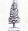
5. Given that represents 10 trees, how many trees are represented by:

?

6. Kato planted 11 trees in a straight line 2 metres from one tree to another. What was the distance between the first and last tree.

7. Describe the shaded part in the Venn diagram below.
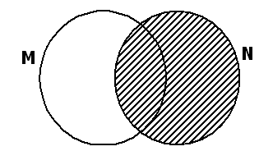

__________________________

8. What name is given to the figure below?

9. Round off 7489 to the nearest hundred.

10. Simplify: 7y + 3x + 2y + 5x.

11. A workman started working at 8 o’clock and spent 2 hours and 30 minutes doing the work. At what time did he complete the work?

12. Find the perimeter of the figure below.
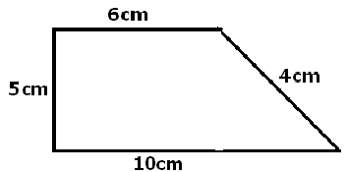

13. There are 158 pupils in P. 4. If there are 74 girls in the class, how many boys are in the class?

14. Subtract: 5 – 3
7 7

15. Find the next number in the sequence: 7, 12, 17, 22, _____.

16. Write down the factors of 18.

17. A book costs Shs. 3,500. Find the cost of 3 similar books.


18. Find the missing number: 36 ÷ = 9.

19. Show a half past 11 o’clock on the clock face below.

20. Add: Kg g
- 650
+ 5 300

SECTION B

21(a) List the first four even numbers. (2 marks)

(b) List odd numbers between 3 and 11. (2 marks)

(c) Find the sum of the numbers listed in (b) above. (2 marks)

22. Given that set Y = {all vowel letters} and

Set T= {the first five letters of the alphabet}

(a) List all members of set Y. (1 mark)

(b) Write all members set T. (1 mark)

(c) Use the information above to complete the Venn diagram below. (3 marks)

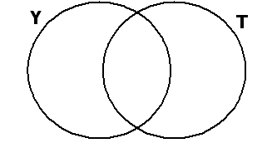

23(a) Add: 1 ⁵/₈ + 2 ²/₈ (2 marks)

(b) What is ¼ of 16 oranges? (2 marks)

(c) Francis had ⁷/₉ of sugarcane. He gave Tom ⁵/₉, what fraction did he remain with?
(2 marks)

24. Use <, > or = to complete the mathematical statements. (1 mark each)

(a) A third ________________ ¹/₃

(b) XXXI _______________ XLIV

(c) 5x3 _____________ 24 ÷ 2

(d) 2 metres ____________ 100cm

25. The figure below is of a rectangle.

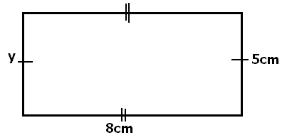

(a) What is the value of y? (1 mark)

(b) Work out the area of the figure. (2 marks)

(c) What is the perimeter of the figure? (2 marks)

26. Find the missing number in the boxes.

(a) + 7 = 19 (2 marks)

(b) 15 – = 7 (2 marks)

27. Janet is 18 years old. Peter is 5 years younger than Janet.

(a) How old is Peter? (2 marks)

(b) Find their total age. (2 marks)

(c) How old will Janet be after 3 years from now? (2 marks)

28. Below is a price list of some items in Mr. Kisaka’s shop.
1 Kg of sugar costs shs.2500
1 bar od soap costs shs. 4000
1 packet of salt costs shs. 600
(a) Madina bought 2 Kg. of sugar. How much did she pay? (2 marks)

(b) Adrian bought 1 bar of soap and 2 packets of salt. How much did he pay? (2 marks)

(c) How much money did Madina and Adrian spend altogether? (2 marks)

29(a) Find the size of angle x in the figure below. (2 marks)
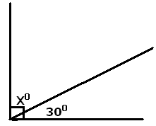

(b) Draw a cuboid in the space provided below. (2 marks)

30(a) Find the difference of the value of 3 and 5 in 2,305. (2 marks)

(b) Expand 25,836 using values. (2 marks)

31(a) Subtract: 5 6 4 1 (2 marks)
- 3 5 9

(b) Change 123_{five} to base ten. (2 marks)

32. The graph shows the number of books used in a P. 5 stream School in a certain week. Use the graph below and answer the questions that follow:
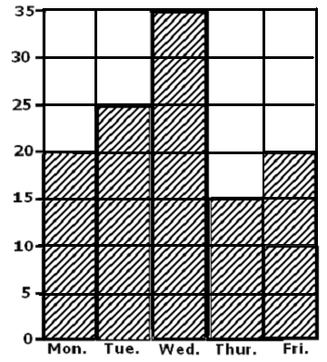

(a) Which day has the largest number of books used? (1 mark)

(b) On which days was the same number of books used?

(c) What is the lowest number of books used?

(d) Find the total number of books used in a week?

